01.04
SB & AD Assessment
Process Design & AMOS Configuration Document
Purpose
This Process Design document is provided to Key-Users to record their key decisions regarding the AMOS Process design and the required AMOS configuration.
It is updated throughout the Project Definition Phase and used as the baseline for the Final Acceptance prior to Go-Live
Revision
Author, Name | Date | Notes
Boris Kazarow | 01.06.2024 | First Version
Boris Kazarow | 18.12.2024 | Second Version  Ch. 1 Updated Process Objectives  Ch. 6 Updated Flowchart

Table of Contents
1. Process Overview & Objectives 3
2. Regulatory References 4
3. Definitions & Glossary 5
4. Process Tasks 5
5. Process Dependencies 6
6. Process Flow 7
7. Process Design Questions 9
8. Data (Source) Mapping 10
9. Other Software Used 10
10. AMOS Configuration 11
a. Basic Data 11
b. Parameters 12
c. Workflows 13
d. Scheduled Tasks 14
e. API’s & Interfaces 14
11. UAT Guidance 14
12. Annex – Additional Info 14

Process Overview & Objectives

Process General Description:
This process allows to perform and track assessment of any types of documents stipulating any types of aircraft as well as component maintenance requirements.
It also provides a summary of this assessment and a performance status per aircraft.
Main Process Objective (Outputs & Outcomes):
This process describes the flow of tasks to enable a collection of all the details necessary to perform a pertinent assessment of AD & SB or any other types of documents, such as AOT, STC/ICA, VSB, MOD, etc.
For a wider range of possibilities to create a document assessment incl. Engineering Assessment, Business Case, Risk Assessment (e.g. for larger organizations or as a CAMO/CAMP service provider) Engineering Orders can be set up (in APN 852) which are incorporated into the tree structure as the sign-off document of the document tree (in APN 63).
The document preparation state and behaviour can be controlled with Release States in APN 63.
Relationships between documents are translated to Signoff-Trees. In a Signoff-Tree, it is defined which documents fulfil the requirements of what document. (E.g. AD compliance is expressed by the performance of one or more SBs. Those SBs may in themselves refer to one or more EOs or Vendor SBs being the sign-off document in this tree which contain the accomplishment instructions that ultimately become the plannable event).
Finally, several modules and reports exist to consult and monitor the modification status of the fleet. Modification Summary Report contains all assessed modification and their status per aircraft.
Weight & Balance affected information can be recorded directly on document level. Upon execution of the document weight & balance data gets updated automatically (cf. Process 01.08 Weight & Balance)
Reporting Back Messages can be set up if the document assessor needs detailed information about the execution of the document.
Special Texts allow additional / specific information to be displayed on the Modification Summary Report.
Requirement Links with a Taskcard can be set to determine the controlling maintenance event that shall transfer execution information to the (to be controlled) document and/or taskcard (cf. Taskcard Type “Document Controlled Taskcard Type” in Process 01.03 Maintenance Program).
Component Documents allow more fields to enter as they influence Rotable related APNs:
- Plate: Triggering an automatic comparison of the information entered in View/Edit Modification (APN: 63) and the information entered during the Component Inspection & Records process (APN: 2293). If the values are identical the matching will be indicated in the “Mod. Info” tab in Rotable Administration (APN: 147)
- New Partnumber: In this tab one or several possible new part numbers can be defined for each for each effectivity. A selection dialogue at the reporting back level has been established where you can select which new part number should be defined for the actual pending. This is especially important for on-wing modifications when the part is not removed.
- Rotable Driven Dependencies: The Auto Assignment code "S" (tabsheet Reporting Back) allows controlling of parts with dependencies to other parts. For example, the modification status of the engine would depend upon the part numbers fitted. In the tab “Rotable Driven Dependencies” you therefore can define all those parts that are dependent to the part number that has been entered in the Effectivity tab with the status “rotable driven”.

Regulatory References

EASA:
- Part M - Continuing Airworthiness Requirements
M.A.301 Continuing airworthiness tasks: This section outlines the continuing airworthiness tasks that the owner or operator must perform, including compliance with ADs and instructions for continued airworthiness.
M.A.304 Data for modifications and repairs: This section requires compliance with mandatory modifications and repairs issued by the competent authority.
M.A.305 Aircraft continuing airworthiness record system: This section details the requirements for keeping records of all maintenance performed, including compliance with ADs and mandatory service bulletins.
- Part CAMO - Continuing Airworthiness Management Organisation
CAMO.A.315 Continuing airworthiness management: This section requires CAMOs to ensure that the aircraft they manage comply with ADs, mandatory service bulletins, and other instructions for continued airworthiness.
- Part 145 - Maintenance Organisations
145.A.42 Acceptance of components: This section ensures that maintenance organizations only accept components that comply with ADs and other continued airworthiness requirements.
145.A.55 Maintenance records: This section mandates that maintenance organizations keep detailed records of all work performed, including compliance with ADs and mandatory service bulletins.
FAA:
- 14 CFR Part 39 - Airworthiness Directives
§ 39.7 Airworthiness Directives: This section states that no person may operate a product to which an AD applies except in accordance with the requirements of that AD.
- 14 CFR Part 121 - Operating Requirements: Domestic, Flag, and Supplemental Operations
§ 121.363 Responsibility for airworthiness: This section requires certificate holders to ensure that each aircraft is maintained in an airworthy condition.
§ 121.373 Continuing analysis and surveillance: This section requires operators to have a system for the continuing analysis and surveillance of their maintenance program, which includes tracking and incorporating ADs.
§ 121.380 Maintenance recording requirements: This section outlines the requirement for operators to keep accurate records of all maintenance, preventive maintenance, alterations, and AD compliance.
- 14 CFR Part 135 - Operating Requirements: Commuter and On Demand Operations and Rules Governing Persons On Board Such Aircraft
§ 135.431 Continuing analysis and surveillance: Similar to § 121.373, this section requires operators to continuously analyze and surveil their maintenance programs, ensuring ADs and mandatory service bulletins are embodied and tracked.
§ 135.439 Maintenance recording requirements: This section mandates accurate maintenance records, including compliance with ADs.
- 14 CFR Part 91 - General Operating and Flight Rules
§ 91.403 General: This section holds the owner/operator responsible for maintaining the aircraft in an airworthy condition, including compliance with ADs and mandatory service bulletins.
§ 91.417 Maintenance records: This section specifies the requirement for maintaining records of maintenance, preventive maintenance, and compliance with ADs.

Definitions & Glossary

Key-Words | Explanation
Engineering Order – EO | Used to perform an evaluation of the time, cost and effort needed to implement a modification
EOC / EOD | Engineering Order Cover (EOC) and Engineering Order Details (EOD) allows the creation of a hierarchical structure, and as required to collect multiple EOD and attach them to an EOC.
AOT | All Operator Telex
STC | Supplemental Type Certificate
ICA | Instructions for Continued Airworthiness (as part of STC)
VSB | Vendor Service Bulletin
AD | Airworthiness Directive
SB | Service Bulletin
MOD | Ex-Factory MOD number

Process Tasks

Business Process Task / Actions / Activities:
- Identify assessable documents: From the technical library process, it is necessary to identify the documents which needs to be assessed, according to internal company procedures.
- Create an Engineering Order: Pending on the company policy, an EO can be created to identify and collect all potential additional information.
- Assess the document / EO: this task leads to the approval decision and will, pending on the decision, trigger the launch of the modification on the fleet/aircraft
Note that for mandatory modifications, the approval can be automatically generated.
- Assign status to each concerned aircraft pending on effectivity and decisions status
- Consult modification status of an aircraft or on fleet level
- Consult modification status of a component

Process Dependencies

INPUT | CONCURRENT | OUTPUT
- 02.05 – Technical Library: Record of all modification documents in AMOS, source of information for the assessment process | - 04.04 – Approval Control: To manage approvals of a document assessment  - 01.03 – Maintenance Program: MP to be potentially updated in case of unlimited repetitive AD or SB action.  - 02.06 – Requirements Work Scoping: Source of information for the assessment process  - 01.05 – Configuration Management: Needs to be updated in case SB implies P/N changes | - 03.01 – Planning: Required for the performance of the modification  - 03.04 – Modification campaign: A modification campaign to be planned and monitored  - 09.04 – Repair & Exchanges: In case the modification has to be performed off.wing  - 10.02 – Goods Receiving & Inspection: Receiving the part back after repair.

Process Flow
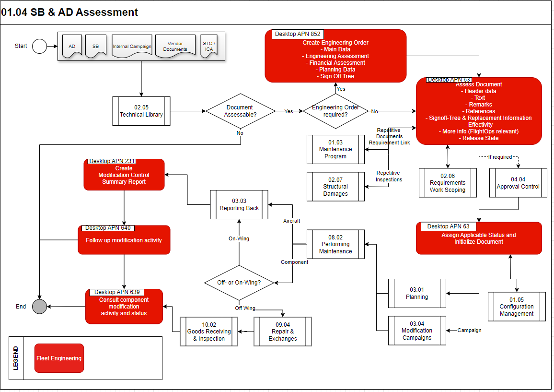

Process Design Questions

# | Question | Answer
1 | Are you tracking component modification or only aircraft modification?
2 | Do you have any internal sign-off tree structure? (e.g. EO is always set as sign-off document or can any document sign-off)
3 | Do you work with different document release states? AMOS allows the following stages: (Unknown, In Preparation, Ready to be Verified, Ready to be released, Released) This influences the ability to initialize a document (see also Parameter 1551).
4 | Do you use an approval process? At what document stage does it happen?
4 | Which kind of communication is used if a document is affecting flight operation or weight and balance? Are there any automatic workflows triggered?
5 | Which effectivity type will be used in order to reflect the affected aircraft?
6 | Do you have to show compliance with your local authority only (e.g. EASA AD) OR you have to show as well compliance with other authorities (e.g. EASA AD & FAA AD)?
7 | Are you using several EOs as working documents?  NOTE:  It is possible to generate more than one EO for the same SB. This allows the engineering to split the task between the affected staff (e.g. B1 separate from B2 work).

Data Source Mapping

Data Sources | Description | Volume / Manual / Automatic / Static / Dynamic
EASA/FAA/NAA Website | -/- | -/-

Other Software Used

Other Softwares | Used by: | Description
-/- | -/- | -/-

AMOS Configuration

Basic Data

Basic Data Table | Notes
Document Type | Table containing all valid documents that can be used in view/edit Modifications
ATA Chapter | Recommended to break down to 4 digits can be useful for analysis and reliability reports
Compliance Type | Compliance requirements with regards to regulation (Ex: AD is always mandatory) or in accordance with internal policy defined for specific applicability (documents, parts, task cards...)
OEM | List of OEM in AMOS necessary to import and manage OEM documents
Document Type of Change | Type of Change: needed to define the type of change per document in View/Edit Modifications program "Main" tab-sheet.  E.g. Minor Change, Major Change, etc. ...
Classification Code | Each Document in View/Edit Modifications can be defined with different Classifications. View/Edit Modifications -> Markings tab-sheet ->Document Classifications tab-sheet. The classifications can be used for search purposes in the document search area.  Example: I = Document under Investigation
Concern Type | All Concern Types can be defined in this table. Needed to enter the concern type in View/Edit Modifications -> Markings -> Document Concerns tab-sheet.
Distribution Type | All distribution types can be defined in this table. Needed to enter the document distribution type in View/Edit Modifications -> Markings -> Document Distribution tab-sheet.
Affect-Type | All "Document Affects" needed in View/Edit Modifications can be entered here. This data is only needed if you want make entries in the View/Edit Modifications -> Markings tab-sheet -> Document Affects tab-sheet.
Method of Compliance | Table to define and manage a list of Methods of Compliance, such as Inspection, Modification, Incorporate into AFM etc., to be used for Documents within Publication Management (APN565), View/Edit Modifications (APN63) and Engineering Orders (APN852) programs, and printed on related reports.
OEM Attachment types

Parameters

Parameter Code | Parameter Name | Notes
1666 | Activate Approval Control in View/Edit Modifications | Used when internal approval processes exist, i.e. different department/positions for the creation and approval of a document exist
1668 | Activate Approval Control in Engineering Orders | Used when internal approval processes exist, i.e. different department/positions for the creation and approval of an EO exist
1387 | Document mg.: length of Docno.-field | Between 20 and 35 allowed
1551 | Document forecast ability depending on which release states
1430 | Basic data for Rotable Mod. Status
1442 | Component document status
1457 | Document 3rd party acceptance
1461 | Delete document status for deleted rotables | Defines the document status which you want to have deleted as soon as removing a rotable from the system.  All other document status except the defined ones will be kept.
1498 | Documents sort order
1665 | Automatically terminate Documents at reporting back

Workflows

Workflow Number | Workflow Name | Workflow Setup Notes
48 | Check Status for Rotable-Driven Documents | This workflow is triggered when a part driven rotable is installed / removed (Label Booking)
66 | Required Parts for a Document | This workflow is triggered if, in View/Edit Modifications, the required parts for a document are entered or changed.
79 | Document Taskcard Link | This workflow is triggered if the effective date or the time-requirement is changed in View/Edit Modification with an existing link to a taskcard.
101 | Workorder issued for a Document (post-save) | This workflow is triggered when a W/O is issued from specified list of Documents.
150 | Document terminated but Workorder still opened | This workflow is triggered when a W/O is still opened after terminating a Document.
167 | Saving of Document Allowed | This workflow allows the user to save the document when the conditions are true.
168 | Document saved | This workflow is triggered when a document is saved.
203 | Copy of document allowed | This workflow allows the user to copy the document when the conditions are true.
230 | Worktemplate Modification | The workflow will be triggered whenever a Work Template is modified. The following actions are possible: CHANGED, DELETED or NEW (for each action a Template Rule exists). To differentiate between the Work Template Requirement References the wildcard `event_type` can be used.
623 | Document PRE-POST effectivity impact | Workflow triggered when we have an effectivity with rule restriction and the applicability changes (mod status)
239 | Release to Modcontrol automatically when approved Template Rule | Workflow triggered on changed of approval request
360 | Saving of Engineering Order | Creation of rule to prevent the saving of the document changes if an approval request exists and the approval is either “Waiting for approval” or “waiting for previous approval”
70 | New EO generated | This workflow is generated when a new engineering order is generated.
361 | Release to ModControl | This workflow allow the user to Release to ModControl the Publication or the E.O. when the conditions are true.

Scheduled Tasks

Scheduled Task Reference | Frequency | Notes
DocumentConsistencyCheckService | once per week | This task will check the consistency of all the existing Documents.

API’s & Interfaces

Reference | Direction | Trigger | Frequency

UAT Guidance

1 | Create new document (airframe) starting from “release to mod control” from Publication Management until release to maintenance forecast (document initialization) (cases are SBs, VSB, standalone AD, SNL)
2 | Create new component modification (as previous scenario)
3 | Create new engineering order for local requirements starting from APN 852 and then release to mod control
4 | Perform revision of previous created mod control item (effectivity and sub tabs)
5 | Link/modify signoff tree
6 | Perform different statuses assignment (open, closed, already performed, superseded etc.)
7 | Perform revisioning of work template (syncing with work templates of pending events)

Annex – Additional Info
-/-

